Gabriela Rodriguez
Mr. Peake
Honors English III- 3rd Block
29 March 2012
Is there enough funding aimed at Endometrial Cancer?
When people think about the cancers that effect women, what most often comes to mind is breast cancer or ovarian cancer. It is no surprise that these two cancers also happen to have the most funding out of the cancers that affect women, breast cancer receiving the most funding. One of the most unheard of cancers affecting women is endometrial cancer, or uterine cancer. Endometrial cancer happens to be the least funded out of all the cancers, though it can be very deadly for those who have it. Compared to cancers which have large organizations associated with them, such as breast cancer, research and publicity for endometrial cancer is relatively small. Although research for endometrial cancer does not receive as much funding compared to breast cancer, partially because of the fact that it is usually less severe compared to breast cancer, officials should still direct more research funding to this type of cancer because its effects can be so devastating to women.
Endometrial cancer is the cancer of the uterus. Like most cancers, endometrial cancer begins to develop when cells begin to divide uncontrollably. Although it may not be the most publicized, endometrial cancer happens to be the most common cancer affecting the female reproductive system (“Patient”). Endometrial cancer usually affects post menopausal women, but for about 25% of women, endometrial cancer occurs before menopause (“Patient”). Symptoms of endometrial cancer include abnormal bleeding, (such as bleeding between periods, heavy bleeding, or post menopausal bleeding), unusual vaginal discharge, weight loss, and pelvic pain/pressure (“Patient”). If a person is experiencing any of these symptoms, the person should report this to a physician. If endometrial cancer is the cause of the symptoms, early detection would greatly increase the chance for survival in patients.
For women with endometrial cancer, there are very few treatment options. When women are first diagnosed, the first treatment they receive is surgery. When women have surgery, they have multiple reproductive parts removed. Women will have a hysterectomy (removal of the uterus), removal of both ovaries and fallopian tubes, and in some cases the lymph nodes in the pelvic area (“Patient”). For some women, particularly women with Stage 1 cancer, surgery will be all the treatment they need (“Patient”). For women with Stage 2 or 3, there of course is chemotherapy or radiation available for further treatment just like for the other types of cancers. All women are different, and because of this, treatment plans may vary. Factors taken into consideration regarding treatment plans include age, childbearing plans, personal concerns, and overall health of the patient (“Patient”). Although it is true that treatment plans vary from patient to patient in any type of cancer, endometrial also has one setback. For endometrial cancer, there is no real standardized treatment, even though there may be common practices. Despite not having standard treatment, endometrial cancer victims have very positive outlooks. If caught early enough endometrial cancer is highly curable (“Uterine Cancer”). According to the MD Anderson Cancer Center, “the survival rate across all stages of endometrial cancer is approximately 84%, but it diagnosed at its stage, survival is 90-95 %”( “Patient”). For women with Stage 2 or 3 cancer, long term survival is less likely. The survival rate for these women is about 40% (“Patient”). As with any type of cancer, chances of survival decrease as the cancer progresses.
With any type of cancer, it is very important to do is to do research on the cancer to try to find new ways to treat patients. When it comes it endometrial cancer research, there is a SPORE. SPORE stands for “Specialized Programs of Research Excellence” (“SPORE”). Currently there are not many research studies going on for endometrial cancer, although some will be going underway. Research for cancer is a part of clinical trials. Clinical trials are broken up into three phases, Phase 1, 2, or 3. These clinical trials are critical in making breakthroughs for cancer treatment. During Phase 3 clinical trials is where real changes to treatment options can be offered to women with gynecological cancers, such as endometrial cancer (“Understanding”). Although great breakthroughs can come out of Phase 3 Trials, not many of them take place. Not many Phase 3 trials take place mainly because they are the most expensive, costing millions of dollars to carry out (“Understanding”). Even fewer Phase 3 clinical trials are going on for endometrial cancer since they receive less funding, but this does not mean there is nothing to be researched. Endometrial cancer, so far, has no screening. Further research could find a way to screen women for this type of cancer. Also, as it was stated before, endometrial cancer also does not have a standardized treatment plan. Research could provide endometrial cancer patients with more answers and chances to improve their quality of life (“Unanswered”). In order to come up with answers, further research will be needed.
Endometrial cancer is the most unfunded of all the cancers. In 2008, the National Cancer Institute (NCI) spent 17.1 million dollars on endometrial cancer. In 2010, the NCI only spent 14.2 million dollars on endometrial cancer (“Cancer”). That’s 2.9 million less over two years. The NCI’s main goal is cancer research, studying the causes, prevention, detection, diagnoses, and treatment of all cancer (“Cancer”). The way the budget is split between the different types of cancer varies depending on several factors. The budget varies on the optimum amount of funding that would be necessary to make most rapid progress against cancer as possible; the budget is then approved by Congress (“Cancer”). In 2010, endometrial cancer received the least amount of funding, verses breast cancer which received the most. 631.2 million dollars was spent from the NCI’s budget on breast cancer research (“Cancer”). From 2008 up until 2010, the NCI consistently spent the most money on breast cancer research, and consistently spent the less on endometrial cancer.
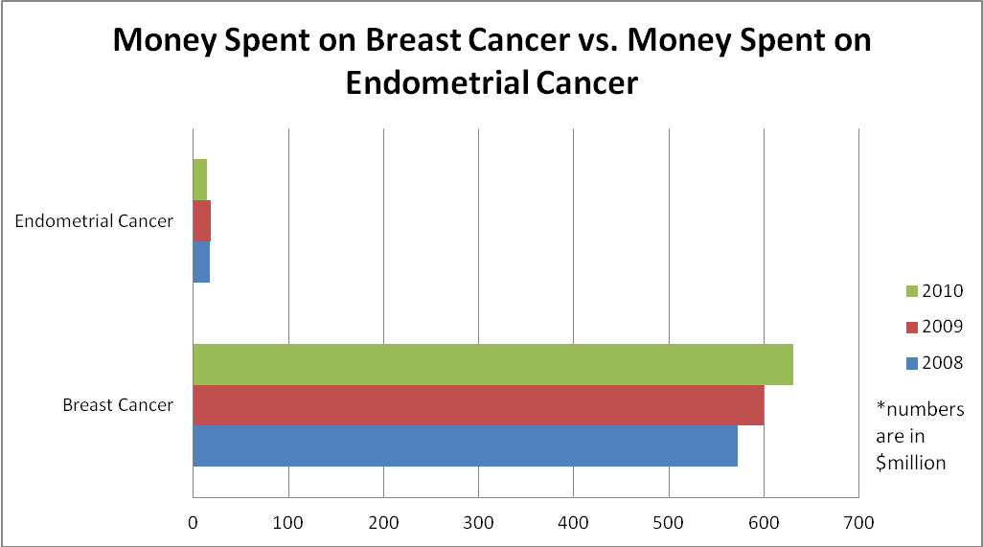
Breast Cancer is the cancer of the breasts. Although it primarily affects women, it can also affect men. Breast cancer is probably the most “popular” of the all the different types of cancers. Its popularity might have something to do with the number of women it affects in the US. About 12% of women will develop invasive breast cancer in her lifetime, that’s one in every eight (“U.S.”). There are 7 different types of breast cancer affecting women all over the US. The most common type of breast cancer is Infiltrating Ductile Carcinoma (“Types”). Like most cancers, breast cancer is divided up into four stages, Stages 1-4. Stage 1 is the least aggressive and stage 4 is the most aggressive. If caught early enough (in stage one) the survival rate for women is 98%, but the rate goes down dramatically at stage four (“Stages”). The survival rate for women with stage four breast cancer is 16% (“Stages”). Although breast cancer may seem like a scary thing for many women, there are screenings in place to catch the cancer early. The two main screenings for breast cancer are self breast exams, and mammograms. Self breast exams can be done at home starting at the age of twenty, and should be done once a month. Mammograms should be done annually starting at the age of fifty. Risk for breast cancer is very similar to that of endometrial cancer, including: age, diet and lifestyle, menstrual and reproductive history, family and personal history, and medical/other factors (“Risk”). Not only does breast cancer affect millions of women, it has the second highest cause of death by cancer (after lung cancer) in women (“U.S.”). Because breast cancer has also impacted the lives of many women in the US, there are organizations besides the NCI, such as the Susan G. Komen foundation, that are trying to find a cure to this type of cancer. For women, the breast is pretty much a symbol of “women hood”. So breast cancer not only has an effect on women physically, but psychologically and emotionally as well. Margaret Woods, a Health Science teacher at Clayton High School, says “People will put their money into something that they feel passionate about. Breast Cancer completely changes a women’s image” (Woods). Margaret Woods also agrees with the fact that having breast cancer may be emotionally challenging (Woods). Margaret agrees that the breast for women is a symbol of “women hood”, making breast cancer emotionally challenging in a different way than other cancers would for women.
As time goes by, it can get more and more difficult to raise funding for any cause. There are many different causes out there competing for the charity dollar, but there is less and less of it every year. For these causes it is getting harder to stand out. Margaret Woods believes that for some of these causes it would take a celebrity to raise the awareness necessary to raise funds (Woods). Two of these causes are breast cancer, and endometrial cancer. Both cancers have their similarities, but also their differences. The biggest similarity to a certain extent is treatment. Both types of cancers undergo some type of surgery followed by either chemo or radiation. What makes the difference in the search for funding are the patients. Woods said “People will put money towards something they feel passionate about” (Woods). So far, it seems as though breast cancer has had no problem finding funding for research, whether it be from the NCI or separate organizations. But endometrial cancer organizations struggle to find and convince organizations to fund research for them. Breast cancer patients hold various events and walks in order to raise money to put forth to the research; this is a less common thing for endometrial cancer. Endometrial cancer patients tend to survive more, and suffer from fewer changes compared to a breast cancer patient whose image has been changed because of the cancer (Woods). When asked how funding for cancer research should be distributed, Margaret Woods said “The most common cancers should get more funding, then the most aggressive” (Woods). According to Margaret’s answer, breast cancer should get more funding than endometrial cancer, and the patients agree. Patients with breast cancer have shown a greater passion in finding the cure to the cancer that affects them. These patients have let their passion drive them in the search for a cure.
Breast cancer and endometrial cancer alike have both impacted and have changed the lives of many women in the US. For both cancers, there is certainly a need to do more research to find a cure and better treatment options for the patients. That need for more research will always be there until a cure is found. In the end one of the types of cancers will need it more than the other. In this case breast cancer needs the funding more. Breast cancer needs the funding because of how much more aggressive it is compared to endometrial cancer. Although not much is known about endometrial cancer, although it lacks standardized treatment, although it lacks a screening test, endometrial cancer has less of a need for more funding for research.
Work Cited
“Cancer Research Funding”. www.cancer.gov The National Cancer Institute, 2012. Web. February 8th, 2012
Woods, Margaret. Personal Interview. March 5th, 2012
“Patient Education”. www.2mdanderson.org The University of Texas MD Anderson Cancer Center, 2009. Web. February 8th, 2012
“Risk Factors” www.nationalbreastcancer.org National Breast Cancer Foundation Inc. Web. February 11th, 2012
“Stages of Breast Cancer”. www.nationalbreastcancer.org National Breast Cancer Foundation Inc. Web. February 11th, 2012
“Types of Breast Cancer”. www.nationalbreastcancer.org National Breast Cancer Foundation Inc. Web. February 11th, 2012
“Unanswered Questions and Controversies”. www.upthevolume.org Up the Volume Foundation, 2012. Web. February 9th, 2012
“Understanding Research and Clinical Trials”. www.upthevolume.org Up the Volume Foundation, 2012. Web. February 9th, 2012
“U.S. Breast Cancer Statistics”. www.breastcancer.org Breastcancer.org, 2012. Web. February 11th, 2012
“Uterine Cancer”. www.upthevolume.org Up the Volume Foundation, 2012. Web. February 9th, 2012
“Uterine Cancer Spore”. www.mdanderson.org The University of Texas MD Anderson Cancer Center, 2009. Web. February 9th, 2012

